**Projects Summary:**

**1. Command Line Calculator**

**Project Overview**

* **Content**:
  + Simple calculator that supports addition, subtraction, multiplication, division, square root, and exponentiation.
  + User selects the operation and enters the numbers.

**Code Explanation**

* **Content**:
  + Functions for each operation (Add, Subtract, Multiply, Divide, Square Root, Power).
  + Example: add(x, y) adds two numbers, divide(x, y) handles division with error checking for zero.

**How It Works**

* **Content**:
  + User selects the operation.
  + Enters numbers based on the operation selected.
  + The program performs the operation and displays the result.

**Tools and Technologies Used:**

* Python

**Result Screenshots:**

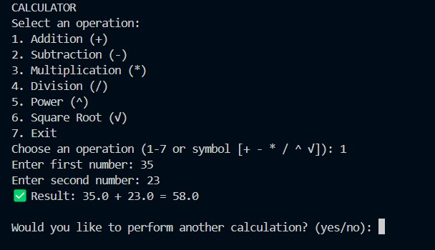

**2. CSV File Analysis**

**Project Overview**

This project loads a CSV file, analyzes the data, and provides basic statistics (mean, median, max, min). Users can filter data based on their input for customized analysis.

**Code Explanation**

* **Data Loading**: CSV file is read using pandas.
* **Statistics**: Calculates mean, median, max, and min for selected columns.
* **Filtering**: Allows data filtering based on user input.
* **Visualization**: Generates basic plots using matplotlib.

**How It Works**

1. Load CSV into a DataFrame.
2. User selects a column or filter condition.
3. Program calculates and displays statistics.
4. Optional visualizations are generated.

**Result Screenshots:**

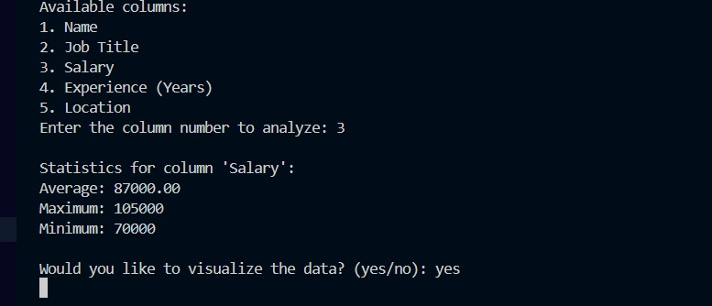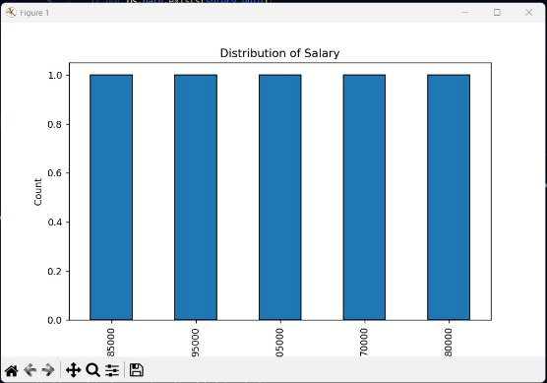

**3. Web Scraping**

**Project Overview**

This project scrapes data from a website using requests and BeautifulSoup, extracting relevant information like article titles, prices, or descriptions. The data is then saved in a structured format (CSV or JSON).

**Code Explanation**

* **Requests**: Used to fetch the webpage content.
* **BeautifulSoup**: Extracts specific data from the HTML.
* **Error Handling**: Manages missing elements and failed requests.

**How It Works**

1. Fetch webpage content with requests.
2. Parse the HTML to extract data using BeautifulSoup.
3. Save the scraped data in CSV or JSON format.

**Result Screenshots:**

